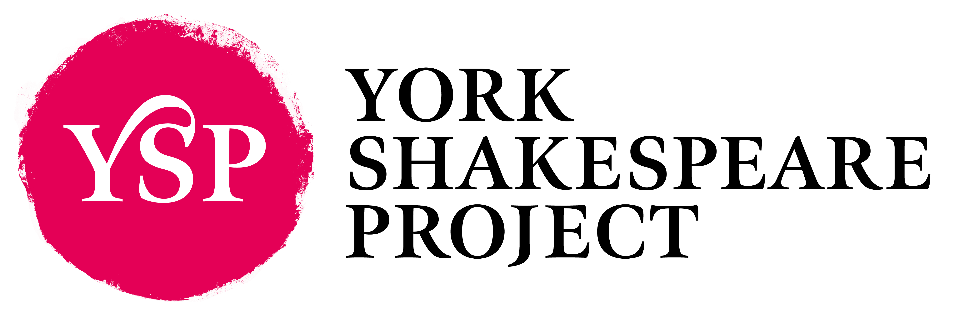

We welcome anyone who wants to support us in our mission: to bring all of Shakespeare’s plays, plus the best work of his contemporaries, to audiences in York.

Membership of the Project entitles you to have a say in the Project's future at our AGM and throughout the year, and enables you to stand for election to the Executive Committee. Being a member also entitles you to accept a role in a show when you are cast.

Memberships are due for renewal each year either on Shakespeare’s birthday, 23rd April, or his half-birthday, 23rd October.

Current Membership Fees

- Standard £15.00
- Couple living at the same address £20.00
- Unwaged £7.50
- 10 Year Membership £100.00

(And if you would like to include a donation that would be great!)

How to join

If possible please pay by BACS to the following account:
Account name: York Shakespeare Project
Sort code: 40-52-40
Account number: 00012235
Please include your name in the payment reference, and email membership@yorkshakespeareproject.org to let us know that you have paid.
Alternatively, you may send cash or a cheque, payable to ‘York Shakespeare Project’, to Annie Charlton, YSP Membership Secretary, 13 White Cross Road, York YO31 8JR.
Once we have received your payment we will add you to the membership mailing list. By purchasing membership you consent to receiving emails from us regarding York Shakespeare Project, but you may opt out of receiving such emails at any time. We will never share your email address with third parties.

York Shakespeare Project
Registered Charity No. 1089509
Patrons: Dame Judi Dench, Adrian Noble, Professor Michael Dobson
www.yorkshakespeareproject.org

